Quantamental investing - From single stock performance to factor exposure (1) – 20260225
This article opens research for the long-time question in my mind: For a given period, the performance of a stock is exposed to what factor (or what kind of risk in risk-control term).
The key will be: To use a factor model and estimate the stock’s factor loadings with regression.
For example, A stock excessive return over risk free in the past three month is to what extend exposed to: US Stock - US Rf Small over Big (IWM - SPY) Total stock market over US market (VT vs VTI) US Stock over US bond (VTI - IEF) Industry over overall stocks (IGV vs SPY) Value over growth (VTV vs VTG)
After that, a stock can be designed to its exposure to above factors.
Take
$MSFT
as an examples in the past 100 days. Most of the drawdown can be explained in three factors: 1. Market transit to small value companies 2. Market appetite change towards bonds, stock over bond effect is weak 3. IGV as an industry indicator is weak against overall stock market
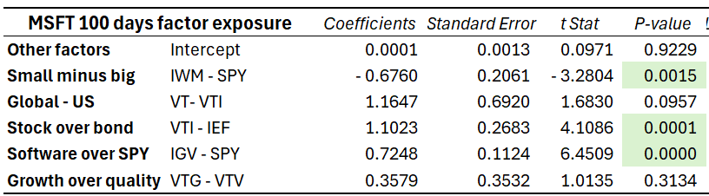
Factors MSFT is exposed to in the past 100 days
In case of doubt on other factors, same significance result with three factors only.
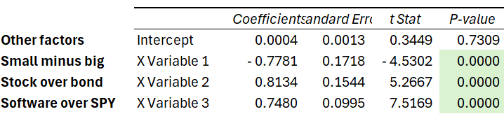

The next steps will be
- looking at quantamental funds about their ideas in investing. E.g. AQR, Millennium, Balyasny, Rayliant Global Advisors, Guggenheim Investments.
- Including factor sentiment for analysis and monitoring

